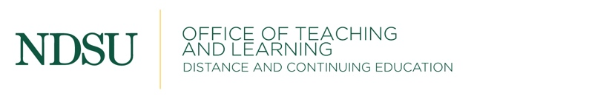

EVALUATION FORM
Return to NDSU Distance & Continuing Education after completion of the course

Title:
Instructor(s):
Date:
Location:

5 = Excellent 4 = Good 3 = Average 2 = Below Average 1 = Poor

PLEASE RATE:

Workshop Presentation 5 4 3 2 1
Workshop Preparation 5 4 3 2 1
Workshop Materials 5 4 3 2 1
Ease In Understanding 5 4 3 2 1
Concern for Individuals 5 4 3 2 1

Group Participation 5 4 3 2 1
Facilities 5 4 3 2 1
Time Workshop was Offered 5 4 3 2 1

PLEASE COMMENT:

POSITIVE AREAS:

AREAS WHERE COURSE CAN BE IMPROVED:

SUGGESTED TOPICS FOR FUTURE COURSES:

HOW DID YOU FIND OUT ABOUT THIS COURSE?

WOULD YOU LIKE TO OFFER A TESTIMONIAL? Y N
If so, please include your first name and city ___________________________________
Please write your testimonial on the back of sheet. (Your testimonial will not be tallied in the results of the evaluation.)

Are you interested in teaching a course for us or do you need a course specifically for your school? If so, please contact Barb Schumacher at 800-726-1724 or 701-231-7852. Check our website at www.ndsu.edu/dce for upcoming courses.

Thank You!

