PHYS 252: University Physics II Course Syllabus
North Dakota State University, Summer 2022
1 Course Description:
The second semester of calculus based introductory physics. Per the NDSU bulletin, we will be studying:
“Electric charge, field, potential, and current; magnetic field; capacitance; resistance; inductance; RC, RL, LC and RLC circuits; waves; optics.”
Room: Ag Hill 300
Time: MTWR 11-12:50
Prerequisites: PHYS 251 or ME 222
Corequisites: MATH 166
Credit Hours: 4
2 Instructor Information:
Instructor: Alistair Mcinerny
Email: Alistair.mcinerny@ndsu.edu
Office: South Engineering 316 (or digitally, link provided on Blackboard) Office Hours: TBD - I will release a poll- or by appointment
3 Course Materials:
Text(s): No required texts but for your benefit here are some resources: University Physics: Volume II and University Physics: Volume III
These books are available for free online at openstax.org, and are linked above. We will be covering chapters 5-16 of Volume II, and chapters 1-4 of Volume III. We’ll be going fast, but I will allow you to set your own pace as much as I can.
We will also be using Blackboard and Lon-Capa for this course.
Lecture recordings, announcements, and exam grades will be on Blackboard.
Homework will be on Lon-Capa.
4 Course Goals and Learning Objectives:
There is one big goal that I have for you during this course. That is:
1. To integrate and apply principles of electricity and magnetism (charge, field, potential, cur rent, circuits, waves, etc.) to solve conceptual and practical problems.
Learning outcomes will be presented as we move through the course, however some examples of these outcomes may be:
1. Explain qualitatively the force electric charge creates
2. Solve for the electric field based on a changing magnetic flux in time

5 Evaluation Procedures and Criteria:

Your final grade in physics 252 will be determined on the following basis:
Homework: 40%
Exams: 60%
· 3 exams 20% each
Extra credit HW problems: 3%

Letter Grading:
89.5 to 100% = A
79.5 to 89.4% = B
69.5 to 79.4% = C
59.5 to 69.4% = D

Homework will be assigned every 2 class periods. Because we are covering a semester of content in 8 weeks the homework load will be fairly demanding. Each assignment will be due a week after it is assigned. The answers will be available the day after the homework is due, so late homework is not an option. Homework provides an opportunity for you to test your own knowledge, and the practice it provides you is important.

There will be 3 tests over the course of 8 weeks. These tests will be examining your ability to connect the material from multiple chapters all together. They will be broken down as follows:
– Test 1: Electricity (chapter 5-10) (June 2, 2022)
– Test 2: Magnetism (chapter 11-16) (June 23, 2022)
– Test 3: Optics (chapter 1-4) (July 7, 2022)
While the tests are not explicitly cumulative, learning is cumulative, and material from a previous section may be critical to solving a current problem. Tests will be available all day on the day they are listed, and you will have 120 minutes to complete them.

6 Attendance
Since this course is hybrid, attendance is not mandatory.
Veterans and student service members with special circumstances or who are activated are encouraged to notify the instructor as soon as possible and are encouraged to provide Activation Orders.
7 Calendar

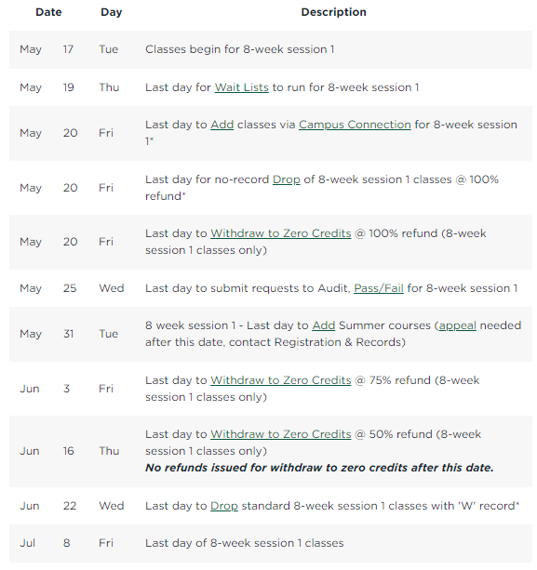
8 Accommodations
Any students with disabilities or other special needs, who need special accommodations in this course, are invited to share these concerns or requests with the instructor and contact the Disability Services Office (www.ndsu.edu/disabilityservices) as soon as possible.
3
9 Academic Honesty Statement
The academic community is operated on the basis of honesty, integrity, and fair play. NDSU Policy 335: Code of Academic Responsibility and Conduct applies to cases in which cheating, plagiarism, or other academic misconduct have occurred in an instructional context. Students found guilty of academic misconduct are subject to penalties, up to and possibly including suspension and/or expulsion. Student academic misconduct records are maintained by the Office of Registration and Records. Informational resources about academic honesty for students and instructional staff members can be found at www.ndsu.edu/academichonesty.
10 Tentative Daily Expectations:
This class is being taught in hybrid form. Class attendance will not be mandatory but is recommended for those that can make it. The benefit of class attendance will be active interaction with clicker questions and your fellow students. For those of you taking the course remotely but duing class time you will also benefit from engaging with clicker questions. For those of you taking the class remotely and asynchronously please attempt to answer any clicker questions, doing so will allow you to assess your own understanding and learning as we go and help highlight when you have not mastered the material.

